Supplementary Materials for

Has land use pushed terrestrial biodiversity beyond the planetary boundary? A global assessment

Tim Newbold^{1,2,*}, Lawrence N. Hudson³, Andrew P. Arnell¹, Sara Contu³, Adriana De Palma^{3,4}, Simon Ferrier⁵, Samantha L. L. Hill^{1,3}, Andrew J. Hoskins⁵, Igor Lysenko⁴, Helen R. P. Phillips^{3,4}, Victoria J. Burton³, Charlotte W.T. Chng³, Susan Emerson³, Di Gao³, Gwilym Pask-Hale³, Jon Hutton^{1,6}, Martin Jung^{7,8}, Katia Sanchez-Ortiz³, Benno I. Simmons³, Sarah Whitmee², Hanbin Zhang³, Jörn P.W. Scharlemann⁸, Andy Purvis^{3,4}

correspondence to: t.newbold@ucl.ac.uk

This PDF file includes:

Materials and Methods
Figs. S1 to S7
Tables S1 to S7

Materials and Methods
The models were based on biodiversity data from the PREDICTS (Projecting Responses of Ecological Diversity In Changing Terrestrial Systems) Project database (21). An extract of this database was taken on 28th April 2015. This extract consisted of 2.38 million records, from 413 published sources (31–437) or unpublished datasets with a published methodology, of the occurrence or abundance of 39,123 species from 18,659 sites in all of the world’s 14 terrestrial biomes. The site-level data used to construct the models are publicly available from the Natural History Museum’s Data Portal (doi: http://dx.doi.org/10.5519/0073893). The data are reasonably representative of major taxonomic groups (Fig. S1A) and of terrestrial biomes (Fig. S1B). For studies where sampling effort differed among the sites sampled, abundance values were corrected by dividing by sampling effort (i.e. assuming that abundance increases linearly with increasing effort). We derived two measures of biodiversity for each of the sites in our dataset: sampled total abundance of organisms and sampled species richness. Because it is not clear which of the many species-based measures of biodiversity most directly relates to the biodiversity-ecosystem functioning research, the main focus of this paper is on abundance-based measures and the corresponding planetary boundary (9).
We considered four human-pressure variables shown previously (3) to explain differences in local biodiversity among sites: land use (Table S7), land-use intensity (Table S7), human population density and distance to the nearest road. Human population density and distance to nearest road were log transformed and rescaled to a zero-to-one scale prior to analysis; proximity to the nearest road (as referred to in the main text) is simply the negative of log-transformed distance to the nearest road, such that higher values indicate higher pressure. We also considered two-way interactions between land use and each of the other variables. We chose these variables for the availability of fine-resolution mapped estimates, which enable spatial projections to be made from the models. Responses of biodiversity to these variables were modelled using generalized linear mixed-effects models. For sampled species richness we used a model with Poisson errors and a log link, while for (log-transformed) sampled total abundance we used a model with Gaussian errors and an identity link. A random effect of study identity was used to account for variation among studies in sampling methods and effort, differences in the taxonomic groups sampled, and coarse spatial differences in climate and other aspects of the environment. A random effect of spatial block nested within study, to take account of the spatial design of sampling. Spatial blocks were defined by the data entrants based on the maps and coordinates of sampled sites. A random slope of land use within study accounted for study-level variation in the relationship between land use and sampled biodiversity. Backward stepwise selection of fixed effects was used to select the minimum adequate model (438), with inclusion or exclusion of terms based on likelihood ratio tests (with a threshold P < 0.05). All models were developed using the lme4 Version 1.1-7 package (439) in R Version 3.2.2 (440). Spatial autocorrelation tests, performed as in (3), showed significant spatial autocorrelation in the model residuals for only slightly more of the modelled datasets than expected by chance: 6.1% in the case of species richness, and 5.9% in the case of total abundance.
To project mapped estimates of local biodiversity in the year 2005, we used fine-resolution maps of each of the four human pressure variables. The maps of land use were generated by downscaling (23) the harmonized land-use dataset for 2005 (441). The harmonized land-use data describe the proportion of each 0.5° (approximately 50 km²) grid cell in each of five land uses (primary vegetation, secondary vegetation, cropland, pasture and urban). We used generalized additive models (GAM) with quasibinomial errors and a logistic link to relate coarse-scale estimates of each of the five land uses to nine putative explanatory variables at fine resolution (30 arc-seconds; approximately 1 km²): evapotranspiration (442), temperature (443), precipitation (443), topographic wetness (444), slope (444), soil carbon (445), accessibility to humans (446), human population density (24) and principal components of land cover (447). We then took the fine-grained fitted values from the GAMs and rescaled them multiplicatively until the aggregated mean for each 0.5° grid cell matched the estimates from the harmonized land-use data. The rescaled fitted values were then subjected to a constrained optimization algorithm, taking into account error estimates from the GAMs, to generate land-use estimates for all five land uses that summed to 1 within each grid cell. We entered the final estimates back into the GAMs as response variables, and the whole procedure was iterated until the mean inter-iteration difference of predicted values was ≤ 0.001. Grid cells under ice or water (448, 449) were excluded from the analysis, and were masked from the final land-use maps. For full details on downscaling methodology see (23). The land-use data are freely available: http://doi.org/10.4225/08/56DCD9249B224.
In a previous study (3), to estimate spatial patterns of land-use intensity, we used generalized linear models (with binomial errors and a logistic link), for each level of intensity within each land use, to relate the proportion of each 0.5° grid cell under this combination of land use and intensity to three explanatory variables: the proportion of the cell under the land use in question, human population density and United Nations sub-region. Information on land-use intensity was obtained from the Global Land Systems dataset (450); see (3) for the reclassification used. To run these generalized linear models for every 30-arc-second grid cell was computationally infeasible. Therefore, we applied the coarse-resolution models developed for the previous study (3) at the fine resolution used here, assuming that the relationships are the same at both scales. We obtained a gridded map of human population density at 30-arc-second resolution and a vector map of the world’s roads from NASA’s Socioeconomic Data and Applications Centre (24, 25). To calculate a gridded map of distance to nearest road, we used Python code written for the arcpy module of ArcMap Version 10.3 (451), first to project the vector map of roads onto an equal-area (Behrmann) projection, then to calculate the average distance to the nearest road within each 782-m grid cell using the ‘Euclidean Distance’ function, and finally to reproject the resulting map back to a WGS 1984 projection at 30-arc-second resolution. Maximum estimated values across the terrestrial surface of human population density and distance to nearest road in 2005 were 8.3% and 20% higher, respectively, than the maximum values observed in the modelled dataset. To ensure that extrapolating did not create unrealistic projections, we set all grid cells with values higher than the maximum observed to be equal to this maximum observed value (this affected 0.002% of grid cells for human population density and 5.6% of grid cells for distance to nearest road). We could not estimate the expected species richness with absolutely no influence of roads because it is impossible to collect a sample of biodiversity under such a situation in the present day.
To generate estimates of the intactness of ecological assemblages in terms of within-sample species richness and abundance, we multiplied the coefficients of the minimum adequate models described above by the proportion of each grid cell under each land-use and use-intensity combination, and by log-transformed and rescaled (using the same rescaling as in the models) human population density or distance to nearest road. We assumed that human population density and distance to nearest road were constant within grid cells. The resulting values were summed across all coefficients and the intercept added to give the model estimate of log-transformed species richness or total abundance within each grid cell. We calculated the exponential of these values to estimate actual species richness and total abundance. Finally, to calculate the relative intactness of assemblages relative to a baseline with no human impacts, we calculated expected species richness and total abundance for a grid cell composed entirely of primary vegetation with minimal human use, with zero human population density, and at a distance to roads equal to the maximum value observed in the modelling data (195 km). Estimating uncertainty analytically for mixed-effects models requires generating an n-by-n matrix, where n is the number of grid cells in the projection; this was computationally intractable. Instead we generated 20 random draws (a greater number would have required a long computer run-time) of values for all of the model coefficients, from a multivariate normal distribution accounting for the covariance among modelled coefficients. These random draws of parameters were used to generate 20 replicate projections, from which 95% confidence limits were calculated for each analysis. All of the calculations described in this paragraph were undertaken using Python code implemented within the arcpy module of ArcMap Version 10.3 (451), using the ‘Raster Calculator’ function; except for the multivariate random draw of coefficient values, which was performed in R Version 3.2.2 using the 'mvrnorm' function in the MASS package Version 7.3-43.
Scholes & Biggs (11) explicitly exclude alien species from the calculation of biodiversity intactness. Because it is not generally known which species are native and which not, we use modelled average compositional similarity between sites in primary vegetation and sites under other land uses as a multiplier on our land-use coefficients (on a 0-1 scale, rescaled such that primary-primary comparisons have a value of 1). To generate these modelled estimates of compositional similarity, we calculated asymmetric pairwise assemblage similarities between all possible pairs of sites within each study in the data set, where one site in the pair was in primary vegetation. Primary vegetation may contain species that are not truly native to an area, especially in landscapes with a long history of human modification; and landscape-level effects of land-use change may have already removed some originally-present species even from sites in primary vegetation. Therefore, our estimates of compositional similarity are likely to be biased upwards. Asymmetric values were used to focus on the probability that a species sampled in non-primary vegetation was also found in primary vegetation. To remove the possibility for pseudo-replication, we selected as independent contrasts all site comparisons on the off-diagonal of a randomized site-by-site matrix (452). Site-by-site matrices were randomised 100 times to generate 100 datasets of independent comparisons. Compositional similarity was measured using an asymmetric version of the Jaccard Index (J) for the projections of species richness, and an asymmetric version of the abundance-based Jaccard Index (J_{a}) (453) for the projections of total abundance:

$$J=\frac{a}{a+c}$$

$$J_{a}=\frac{UV}{V}$$

where a is the number of species shared between the two sampled sites, c is the number of species only found in the site not in primary vegetation, U is the summed relative abundance in the primary-vegetation site of all species found in both sites, and V is the summed relative abundance in the non-primary site of all species found in both sites.
Assemblage compositional similarities in each of the 100 datasets were modelled as a function of the combination of land uses represented and the distance (geographic, climatic and elevational) between sites. Full details of how assemblage compositional similarity was modelled are given in (22). Average coefficients across the 100 models describing average compositional similarity between primary vegetation and all other land uses (including primary vegetation itself) were rescaled so that comparisons of primary vegetation to itself had a value of 1 (to avoid conflating natural spatial turnover with land-use impact). These rescaled coefficients were then multiplied by the modelled coefficients describing differences in species richness and total abundance among land uses, to estimate the number of species or individuals present in each land use that are also expected to be present in primary vegetation. The rescaled coefficients are publicly available from the Natural History Museum’s Data Portal (doi: http://dx.doi.org/10.5519/0073893).
Although our way of calculating BII differs from that proposed by Scholes & Biggs (11), we also attempt to estimate the “average abundance of a large and diverse set of organisms in an area, relative to their reference populations” (11). If I_{ijk} is the population of species group i in ecosystem j under land use k, relative to a pre-industrial population in the same ecosystem type, then Scholes & Biggs (11) define the biodiversity intactness index (BII) to be:

BII = 100 x (Σ_{i}Σ_{j}Σ_{k}R_{ij}A_{jk}I_{ijk}) / (Σ_{i}Σ_{j}Σ_{k}R_{ij}A_{jk})

where R_{ij} is the species richness of taxon i in ecosystem j and A_{jk} is the area of ecosystem j under land use k. Scholes & Biggs (11) used expert opinion when estimating average BII for seven southern African countries, in the absence of sufficient primary data. They considered birds, mammals, amphibians, reptiles and angiosperms but not arthropods, again because of a lack of information.
Our implementation of the BII differs in that we have used primary data on sampled local species abundance – for a wide range of animal (vertebrates and invertebrates), plant and fungal taxa – in place of expert opinion, and our statistical models incorporate other pressures as well as land use itself. Rather than weighting by areas of ecosystems and species-richness of taxa, we have collated and analysed a data set that is reasonably representative in terms of biomes (Fig. S1B) and taxa (Fig. S1A). Our data set is not yet adequate to support fitting models for each biome and taxon separately, which may lead to our estimates being biased for some biomes. Despite our very large number of records, hierarchical mixed-effects models for individual biomes or taxa would require data from a larger number of published studies than is available for some taxa and biomes. As in (11), in the absence of pre-industrial data, we have used minimally-impacted sites as the reference condition.
We overlaid our estimates of the intactness of ecological assemblages with global maps describing the distribution of biomes (449), Conservation International’s biodiversity hotspots (28), Conservation International’s High Biodiversity Wilderness Areas (454) and human population density (24). All of these overlays were performed using Python code for ArcMap Version 10.3 (451), using the ‘Zonal Statistics’ functions after first projecting all maps into an equal-area (Behrmann) projection.

Fig. S1.
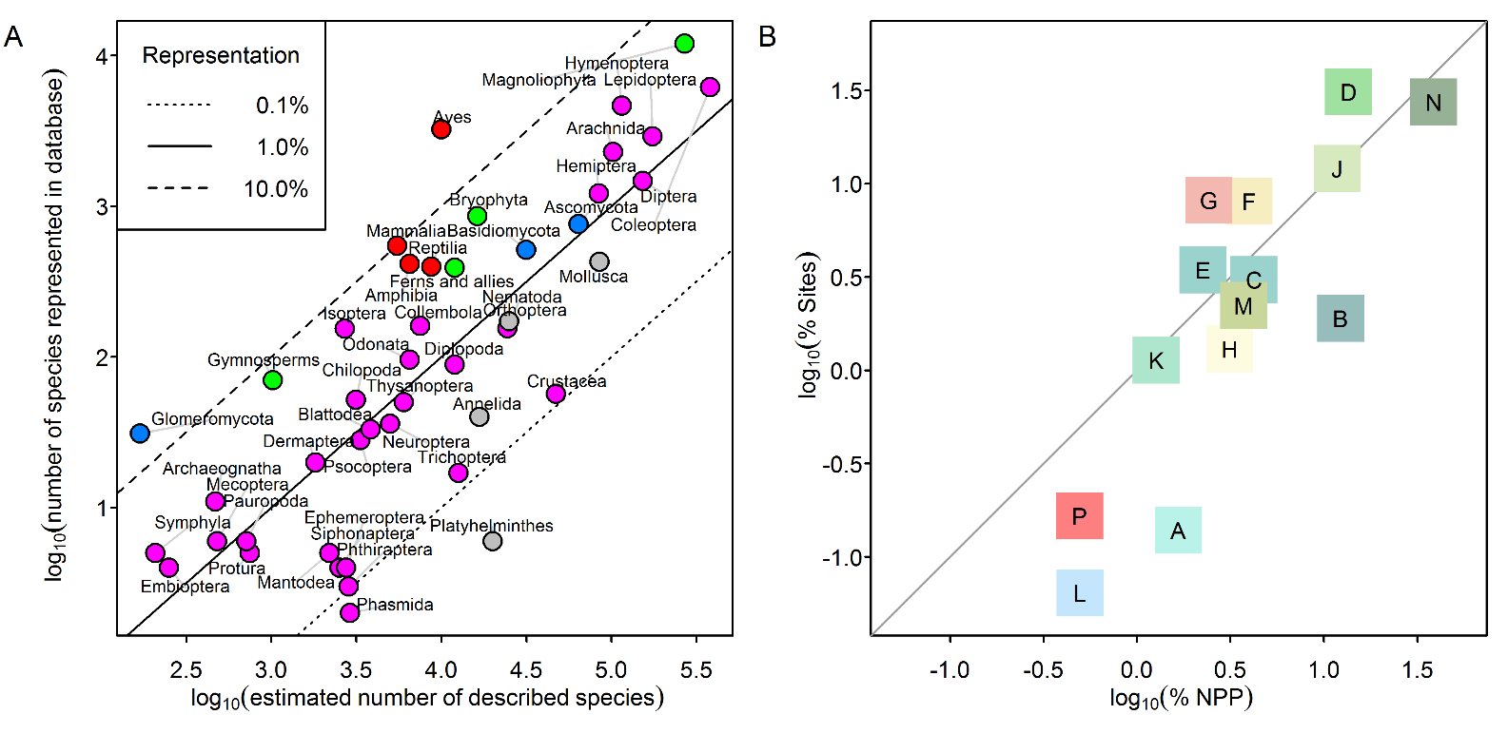
Fig. S1. Taxonomic (A) and biogeographic (B) representativeness of the records used to model biodiversity responses to land use. (A) Correlation, for major taxonomic groups (magenta ‒ invertebrates; red‒ vertebrates; green ‒ plants and fungi; grey ‒ other), between the estimated number of described species (455) and the number of species represented in the dataset. (B) Correlation between the percentage of global primary productivity within a biome (449) and the percentage of sites in the dataset within that biome (A: Tundra; B: Boreal forests/taiga; C: Temperate conifer forests; D: Temperate broadleaf and mixed forests; E: Montane grasslands and shrublands; F: Temperate grasslands, savannas and shrublands; G: Mediterranean forests, woodland and scrub; H: Deserts and xeric shrublands; J: Tropical and subtropical grasslands, savannas and shrublands; K: Tropical and subtropical coniferous forests; L: Flooded grasslands and savannas; M: Tropical and subtropical dry broadleaf forests; N: Tropical and subtropical moist broadleaf forests; P: Mangroves).

Fig. S2
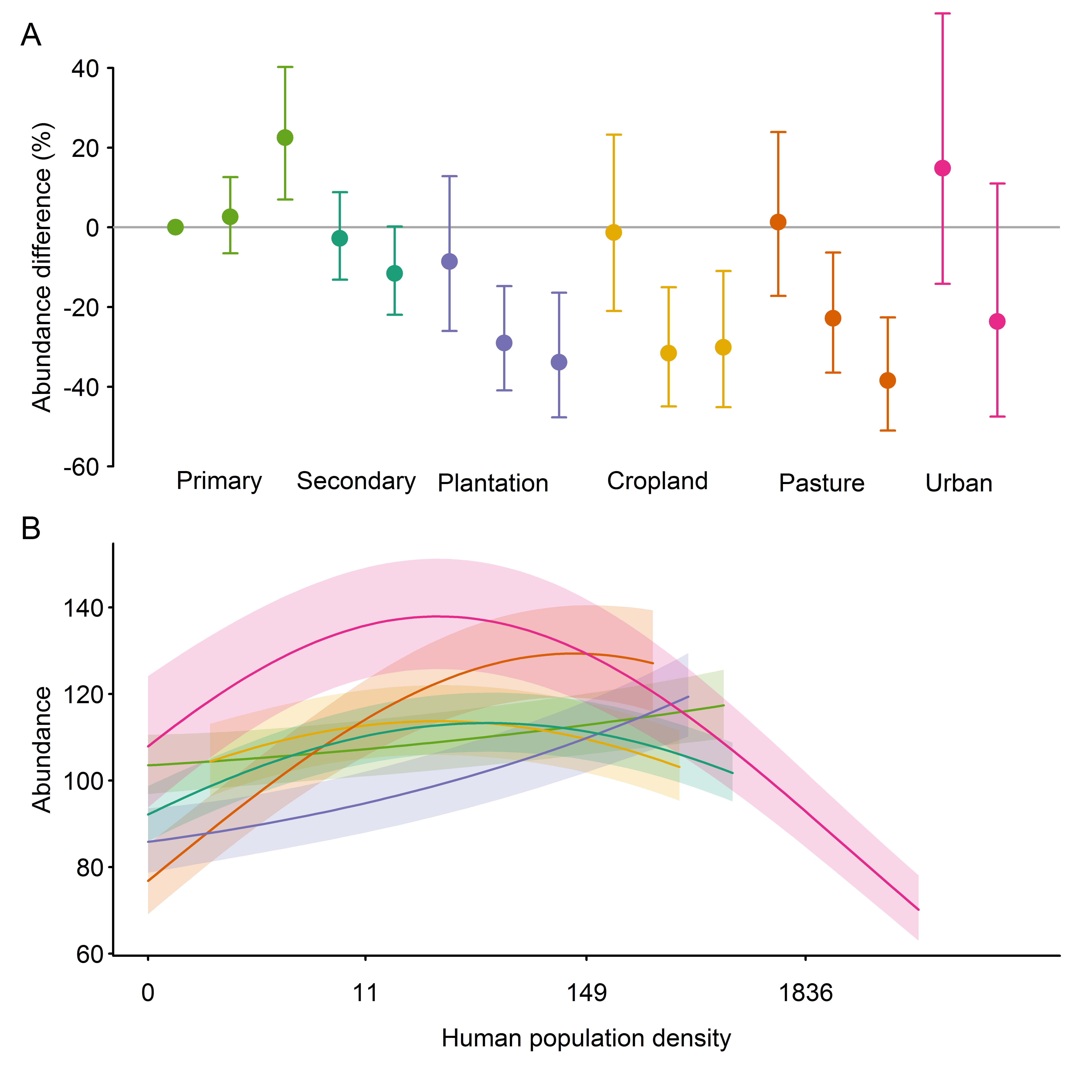
Fig. S2. Response of sampled total abundance to human pressures: (A) land use, and (B) the interaction between land use and human population density. Human population is shown on a rescaled axis (as fitted in the models). (A) shows total abundance as a percentage of that found in minimally used primary vegetation, with 95% confidence intervals; multiple points within each land-use type show, from left to right, increasing intensity of human use (two classes for secondary vegetation and urban; three classes for all other land uses). B shows absolute mean total abundance for a given combination of pressures, with shading indicating ±0.5 × SEM, for clarity. Land uses in B are shown in the same colours as in A. Mixed-effects models are robust to unbalanced designs (456), such as the data spanning different ranges of human population density for each of the land uses. Dropping all urban sites almost no effect on the other model coefficients (Fig. S6). Full statistical results are given in Table S5.

Fig. S3
Fig. S3. Response of sampled species richness to human pressures: (A) land use, (B) the interaction between land use and human population density, and (C) the interaction between land use and distance to nearest road. Human population and distance to nearest road are shown on rescaled axes (as fitted in the models). (A) shows species richness as a percentage of that found in minimally used primary vegetation, with 95% confidence intervals; multiple points within each land-use type show, from left to right, increasing intensity of human use (two classes for secondary vegetation and urban; three classes for all other land uses). B and C show absolute mean species richness for a given combination of pressures, with shading indicating ±0.5 × SEM, for clarity. Land uses in B and C are shown in the same colours as in A. Mixed-effects models are robust to unbalanced designs (456), such as the data spanning different ranges of human population density for each of the land uses. Dropping all urban sites almost no effect on the other model coefficients (Fig. S7). Full statistical results are given in Table S6.

Fig. S4
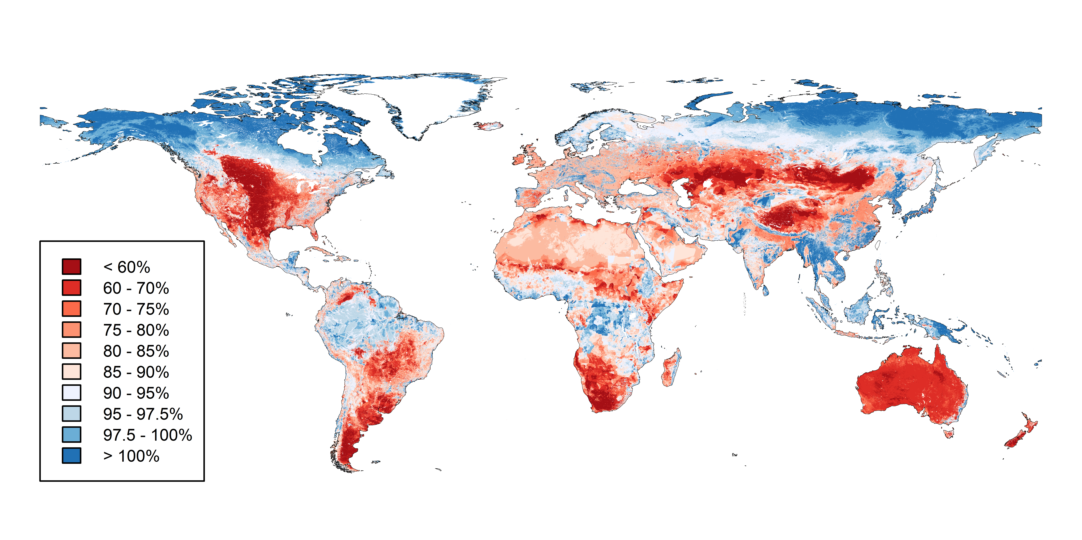
Fig. S4. Biodiversity intactness of ecological assemblages in terms of the total abundance of originally occurring species, as a percentage of their total abundance in minimally disturbed primary vegetation (Biodiversity Intactness Index; BII). Blues areas are those within, and red areas those beyond proposed (9) safe limits for biodiversity, in terms of BII. A high-resolution raster of this map can be freely downloaded (doi: http://dx.doi.org/10.5519/0009936).

Fig. S5
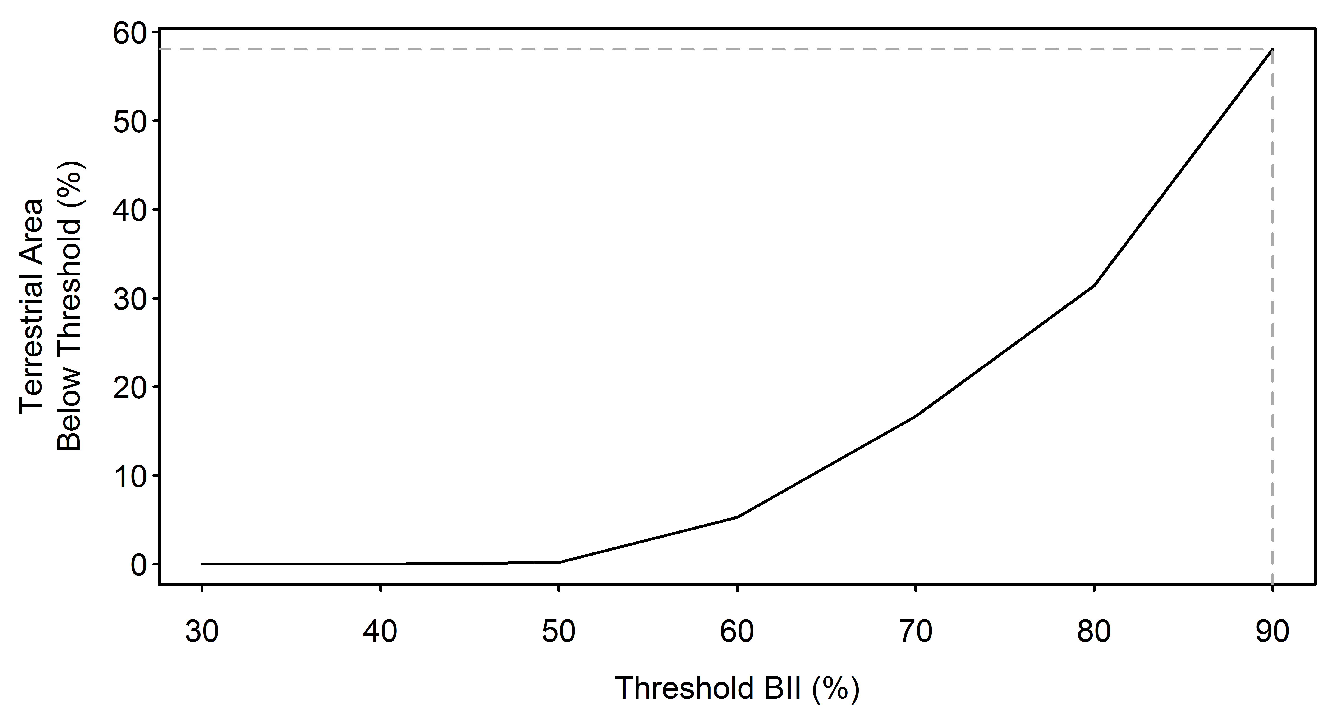
Fig. S5. The proportion of the terrestrial surface exceeding the proposed (9) planetary boundary across the range of uncertainty in the boundary's position. Steffen et al. (9) suggested that the planetary boundary for BII could range anywhere between 30 and 90%, which has a large effect on the proportion of the land surface exceeding the boundary. The dashed grey line indicates the 58.1% of terrestrial area that falls below the precautionary BII threshold of 90%.

Fig. S6
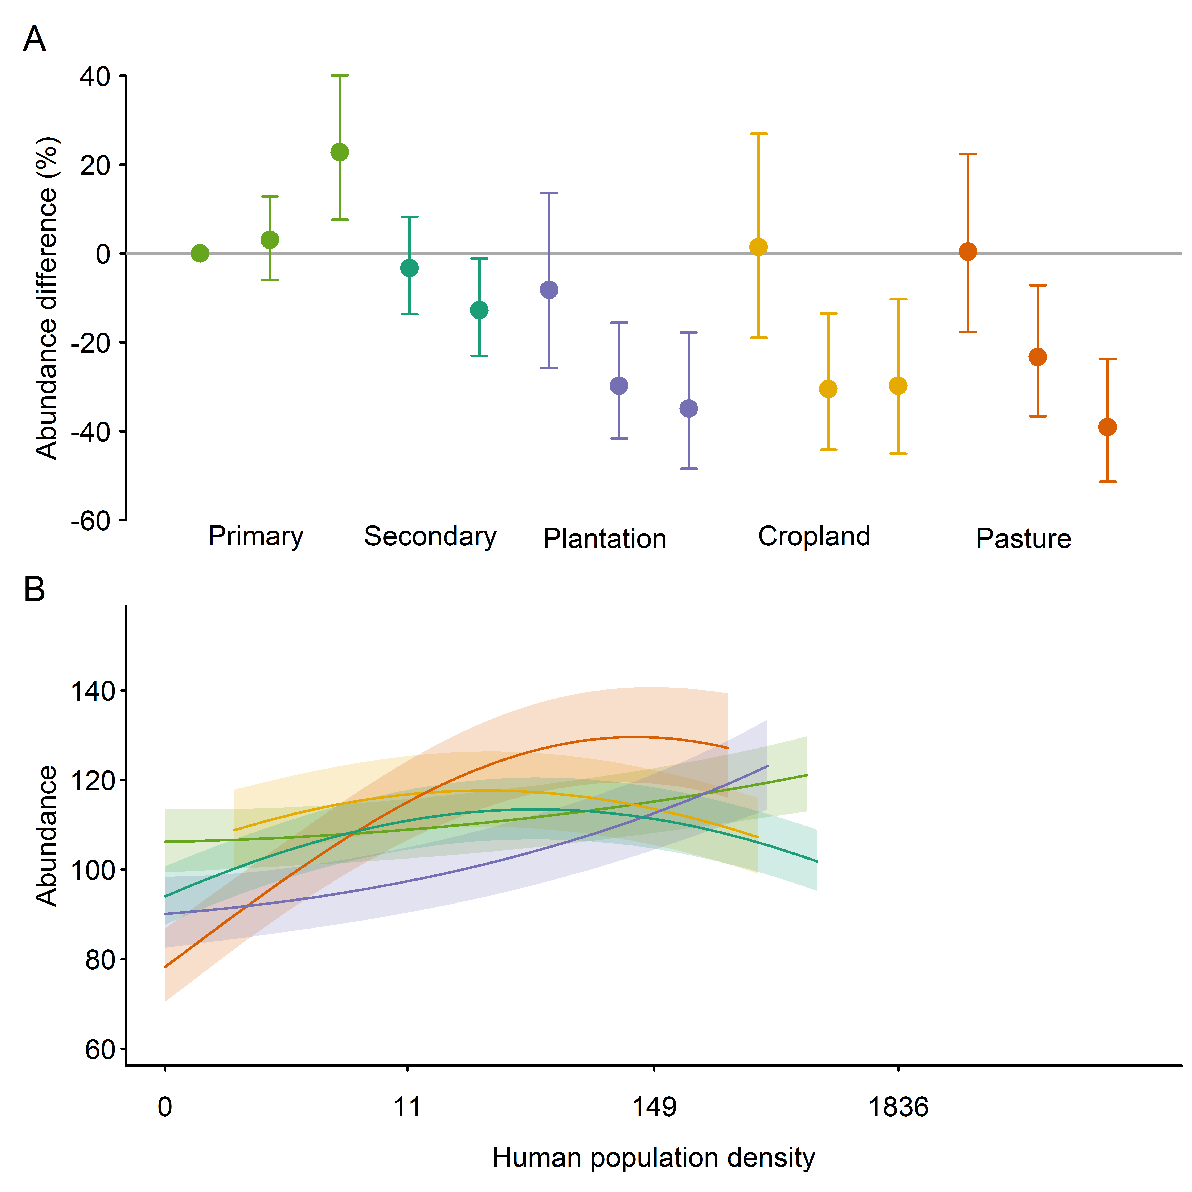
Fig. S6. In models with no urban sites, the response of sampled total abundance to human pressures: (A) land use, and (B) the interaction between land use and human population density. The modelled coefficients are robust to the exclusion of urban sites, which cause an unbalanced design. All plotting conventions are as in Fig. S2.

Fig. S7
Fig. S7. In models with no urban sites, the response of sampled species richness to human pressures: (A) land use, (B) the interaction between land use and human population density, and (C) the interaction between land use and distance to nearest road. The modelled coefficients are robust to the exclusion of urban sites, which cause an unbalanced design. All plotting conventions are as in Fig. S3.

Table S1.
Table S1. Numbers of species represented in the dataset by major taxonomic group, both for species represented in the complete dataset and species with only abundance data.
Taxon | N species (all data) | N species (abundance data)
Amphibia | 415 | 365
Annelida | 40 | 40
Arachnida | 2288 | 2288
Archaeognatha | 11 | 11
Ascomycota | 762 | 613
Aves | 3232 | 3033
Basidiomycota | 514 | 399
Blattodea | 33 | 33
Bryophyta | 862 | 694
Chilopoda | 52 | 52
Coleoptera | 6164 | 5955
Collembola | 161 | 155
Crustacea | 57 | 52
Dermaptera | 20 | 20
Diplopoda | 89 | 89
Diplura | 1 | 1
Diptera | 1475 | 1475
Embioptera | 4 | 4
Ephemeroptera | 4 | 4
Ferns and allies | 392 | 332
Fungoid protists | 1 | 1
Glomeromycota | 31 | 31
Gymnosperms | 70 | 57
Hemiptera | 1214 | 1214
Hymenoptera | 4639 | 4338
Isoptera | 154 | 109
Lepidoptera | 2911 | 2849
Magnoliophyta | 11995 | 9003
Mammalia | 547 | 500
Mantodea | 5 | 5
Mecoptera | 6 | 6
Mollusca | 429 | 378
Nematoda | 172 | 172
Neuroptera | 36 | 36
Odonata | 96 | 96
Onychophora | 1 | 1
Orthoptera | 155 | 154
Pauropoda | 6 | 6
Phasmida | 2 | 2
Phthiraptera | 3 | 3
Platyhelminthes | 6 | 6
Protura | 5 | 5
Psocoptera | 28 | 28
Reptilia | 397 | 335
Siphonaptera | 4 | 4
Symphyla | 5 | 5
Thysanoptera | 50 | 50
Thysanura | 1 | 1
Trichoptera | 17 | 17
Zoraptera | 1 | 1
Other | 243 | 192

Table S2.
Table S2. Biodiversity intactness of the world’s terrestrial biomes (449) in terms of species richness (‘richness’) and total organism abundance (‘abundance’), colour coded according to the status of biodiversity with respect to boundaries proposed as safe limits for ecosystem function (5, 9): red = boundary crossed (> 20% loss of richness; > 10% loss of abundance); orange = boundary approached (>10% loss of richness; > 5% loss of abundance); green = not close to boundary. Values are given as overall net changes including species not found in primary vegetation (‘all species’) and intactness considering only originally present species (‘original species’). Text in parentheses indicates 95% confidence limits.
Biome | Intactness (abundance) |  | Intactness (richness)
 | All species | Original species | All species | Original species
Temperate Grasslands, Savannas and Shrublands | 73 (67.3 - 85) | 68 (62.8 - 78.3) | 67.6 (60.7 - 76.4) | 65.2 (61 - 76.9)
Mediterranean Forests, Woodlands and Scrub | 83.1 (76.7 - 90.1) | 78.3 (73.9 - 87) | 71.8 (65 - 82.7) | 69.8 (65.5 - 82.7)
Montane Grasslands and Shrublands | 82 (73.9 - 93.7) | 77.1 (71.4 - 89.1) | 72.4 (67.4 - 81.8) | 70.2 (66.3 - 81.9)
Tropical and Subtropical Grasslands, Savannas and Shrublands | 85.5 (76.5 - 97.9) | 80.5 (73.9 - 91.9) | 74.1 (68.3 - 85.3) | 72 (68 - 84.8)
Flooded Grasslands and Savannas | 85.7 (79.1 - 96.2) | 81.1 (77 - 90.8) | 74.2 (68.4 - 85) | 72.2 (68 - 84.8)
Temperate Broadleaf and Mixed Forests | 90 (80.2 - 99.5) | 85.9 (79.2 - 96.1) | 74.8 (67.5 - 86.2) | 73.1 (66.6 - 86.3)
Tropical and Subtropical Dry Broadleaf Forests | 90.1 (81.1 - 99.9) | 86.3 (79.9 - 96.3) | 75.9 (69.4 - 87.6) | 74.4 (68.4 - 87.5)
Deserts and Xeric Shrublands | 82 (75.6 - 93) | 78.3 (73.5 - 86.7) | 76.2 (71 - 85.1) | 74.5 (71.6 - 85.5)
Tropical and Subtropical Coniferous Forests | 95 (85.2 - 105.1) | 90.9 (84.4 - 102.9) | 77.2 (70.5 - 90) | 75.6 (68.1 - 89.2)
Mangroves | 95.6 (84.8 - 108) | 92.2 (84.4 - 104.9) | 78.9 (72.5 - 89.9) | 77.5 (69.8 - 89.6)
Temperate Conifer Forests | 89.2 (84.3 - 94.7) | 86.2 (83 - 91.9) | 79.2 (73.8 - 89.1) | 78 (74.5 - 89)
Tropical and Subtropical Moist Broadleaf Forests | 95.9 (89 - 104) | 93.2 (88.7 - 101.4) | 82.8 (77.4 - 92.8) | 81.7 (75.7 - 92.4)
Boreal Forests/Taiga | 96.3 (92.7 - 99) | 95.5 (92.3 - 98.1) | 88.8 (84.1 - 96.9) | 88.5 (85.9 - 96.8)
Tundra | 99.7 (98.5 - 100.7) | 99.5 (98.4 - 100.4) | 94.8 (91.8 - 100.1) | 94.8 (93.2 - 99.8)

Table S3.
Table S3. Biodiversity intactness of the world’s terrestrial Biodiversity Hotspots (28) in terms of species richness (‘richness’) and total organism abundance (‘abundance’). Colours and labels are as in Table 1. Text in parentheses indicates 95% confidence limits.
Hotspot | Intactness (abundance) |  | Intactness (richness)
 | All species | Original species | All species | Original species
Cape Floristic Region | 72.5 (62.9 - 89.3) | 66.5 (59 - 80.4) | 67.2 (60.2 - 78.7) | 64.4 (60 - 78)
Succulent Karoo | 64.2 (50.3 - 87) | 59.4 (52.8 - 79.6) | 67.8 (60.1 - 78.1) | 65.2 (58.2 - 82.3)
New Zealand | 72.5 (63.7 - 86.2) | 68.1 (62.7 - 79.8) | 70.2 (63.5 - 79.7) | 68 (63.4 - 80.9)
Southwest Australia | 73.5 (64.4 - 84.6) | 69.8 (63.5 - 79.5) | 71.4 (64.1 - 80) | 69.6 (64.8 - 81.5)
Maputaland-Pondoland-Albany | 82.6 (76.3 - 93) | 77.2 (73.1 - 88.8) | 71.7 (65.4 - 84.3) | 69.3 (65.6 - 83.5)
Mediterranean Basin | 87.4 (77.6 - 98.6) | 82.1 (74.5 - 95.2) | 71.9 (64.4 - 83.9) | 69.8 (62.8 - 83.5)
Mountains of Central Asia | 86.2 (76.2 - 99.5) | 80.7 (73.7 - 94.2) | 72.4 (65.7 - 84) | 70.1 (63.9 - 83.2)
Cerrado | 80.2 (72.2 - 91.7) | 75.7 (69.7 - 85.7) | 72.9 (67.6 - 82.5) | 70.9 (66.8 - 82.4)
Caucasus | 90.3 (78.9 - 102.9) | 85.3 (76.7 - 99) | 73.1 (65.1 - 86.2) | 71.1 (63.1 - 84.9)
Madagascar and the Indian Ocean Islands | 89.6 (77.6 - 106.2) | 83.6 (74.7 - 99) | 73.1 (66.2 - 87.5) | 70.7 (64.2 - 85.6)
Irano-Anatolian | 92.3 (81.2 - 107) | 86.7 (78.4 - 102.4) | 73.6 (65.9 - 86.9) | 71.4 (62.9 - 85.6)
Atlantic Forest | 89.8 (79.8 - 102) | 84.8 (77.8 - 97.3) | 73.8 (66.6 - 86.2) | 71.7 (64.3 - 85.2)
Caribbean Islands | 92.9 (80.1 - 108.1) | 88.1 (77.5 - 104.3) | 74.3 (66.8 - 88.1) | 72.5 (64.3 - 86.5)
California Floristic Province | 83.4 (78.6 - 87.6) | 80.1 (75 - 86.5) | 74.5 (68.6 - 83.9) | 73.1 (69.9 - 84.1)
Mountains of Southwest China | 90.4 (80.2 - 103.6) | 85.5 (78.6 - 98.4) | 74.6 (67.8 - 86.7) | 72.5 (65.1 - 85.9)
Horn of Africa | 88.3 (76.7 - 103.4) | 83.1 (75.1 - 96.1) | 74.6 (68.3 - 87.7) | 72.4 (67.1 - 86)
Himalaya | 90.4 (80.4 - 101.8) | 86.2 (78.8 - 99) | 74.7 (68.2 - 86.2) | 72.9 (66 - 86)
Coastal Forests of Eastern Africa | 95.8 (85.2 - 111.9) | 90.2 (81.7 - 105.1) | 76 (68.8 - 89.9) | 73.9 (65.8 - 88.8)
Eastern Afromontane | 99.5 (86 - 113.4) | 94.1 (84.9 - 112.8) | 76.6 (69.5 - 90.6) | 74.7 (65.1 - 90.3)
Philippines | 94.9 (78 - 114.4) | 91.6 (77.7 - 106.5) | 76.7 (68.7 - 89.1) | 75.5 (66.1 - 88.8)
Madrean Pine-Oak Woodlands | 91.8 (83 - 102.8) | 87.6 (82.4 - 97.4) | 76.8 (70.4 - 89) | 75.1 (69 - 88.1)
Western Ghats and Sri Lanka | 99.1 (79.9 - 122.9) | 95.7 (80.4 - 113.9) | 77.1 (69 - 90.8) | 75.9 (66.4 - 90.5)
Guinean Forests of West Africa | 100.9 (87.2 - 114.7) | 95.6 (86.9 - 113.8) | 77.1 (69.5 - 91.8) | 75.2 (66 - 91.6)
Mesoamerica | 96.4 (86.3 - 108) | 92.1 (85.4 - 104.1) | 77.9 (71 - 91.1) | 76.2 (68.4 - 90.3)
Tumbes-Choco-Magdalena | 93.5 (84.5 - 105.9) | 89.3 (83 - 100.1) | 78.1 (71.9 - 90) | 76.4 (69.2 - 88.9)
Polynesia-Micronesia | 91.8 (85 - 99.2) | 88.8 (85.2 - 96.5) | 78.2 (72.8 - 90) | 77 (72.1 - 89.5)
Tropical Andes | 91.6 (84.1 - 102.2) | 87.9 (83.2 - 96.4) | 78.7 (72.8 - 90.9) | 77.2 (72 - 90.1)
Japan | 100.9 (85.2 - 114.5) | 97.7 (85.9 - 114.7) | 79.1 (71 - 93.5) | 78 (70.3 - 93.5)
Chilean Winter Rainfall and Valdivian Forests | 91.2 (84.7 - 100.1) | 88.1 (84.4 - 95.6) | 79.9 (74.5 - 91.5) | 78.6 (74.7 - 90.9)
Indo-Burma | 98.3 (83.6 - 112.5) | 95.8 (85 - 107.9) | 80.6 (72.7 - 93.7) | 79.7 (71 - 93.4)
Sundaland | 96.5 (86.5 - 106.7) | 94.4 (87.5 - 102.5) | 82.1 (75.4 - 92.9) | 81.3 (74.2 - 92.8)
New Caledonia | 97.4 (90.9 - 102.8) | 95.5 (91.2 - 102.2) | 83.1 (75.5 - 94.7) | 82.2 (79.2 - 95.3)
Wallacea | 100.5 (88.1 - 111.4) | 98.7 (90.3 - 108.6) | 83.5 (76 - 96.5) | 82.8 (74.8 - 96.3)
East Melanesian Islands | 104 (91.3 - 114.1) | 103.4 (94.5 - 112.1) | 90.5 (83.9 - 101.5) | 90.2 (82.2 - 102.5)

Table S4.
Table S4. Biodiversity intactness of the world’s High Biodiversity Wilderness Areas (454) in terms of species richness (‘richness’) and total organism abundance (‘abundance’). Colours and labels are as in Table 1. Text in parentheses indicates 95% confidence limits.
High Biodiversity Wilderness Area | Intactness (abundance) |  | Intactness (richness)
 | All species | Original species | All species | Original species
North American Deserts | 76.6 (67.1 - 90.9) | 72.2 (66.1 - 85.6) | 72.5 (66.8 - 82.2) | 70.4 (66 - 83.7)
Miombo-Mopane Woodlands and Savannas | 90.9 (79.6 - 105.9) | 86.6 (77.8 - 97.9) | 77.7 (71.8 - 89.5) | 76 (70.2 - 89)
Congo Forests | 96.5 (86.9 - 107.8) | 93.9 (85.3 - 102.3) | 83.3 (77.5 - 95.5) | 82.3 (76.6 - 95.8)
New Guinea | 99 (91.7 - 105.5) | 97.8 (93.1 - 102.9) | 89.3 (85 - 97) | 88.8 (83.5 - 97.5)
Amazonia | 94.9 (90.7 - 98.8) | 93.6 (90.5 - 97.1) | 89.4 (86.3 - 94.8) | 88.8 (86.7 - 94.8)

Table S5.
Table S5. Results of backward stepwise model selection (457) on model of sampled total abundance. Terms considered were land use (LandUse), land-use intensity (UseIntensity), human population density (HPD), distance to nearest road (DR), and interactions between land use and the other variables. Interaction terms were compared first, and then removed to test main effects. HPD and DR were fitted as quadratic polynomials. We report here chi-square values (χ²), degrees of freedom (DF) and P-values (P). Variables within significant interactions were retained in the final model, even if the main effect of that variable was not significant.
Term | χ² | DF | P
LandUse | 9.42 | 5, 33 | 0.093
UseIntensity | 33.6 | 2, 28 | < 0.001
HPD | 13.7 | 1, 28 | < 0.001
DR | 0.382 | 1, 35 | 0.54
LandUse:UseIntensity | 62.2 | 13, 53 | < 0.001
LandUse:HPD | 21.7 | 10, 53 | 0.017
LandUse:DR | 13.8 | 10, 63 | 0.18

Table S6.
Table S6. Results of backward stepwise model selection (457) on model of sampled species richness. Terms considered were land use (LandUse), land-use intensity (UseIntensity), human population density (HPD), distance to nearest road (DR), and interactions between land use and the other variables. Interaction terms were compared first, and then removed to test main effects. HPD and DR were fitted as quadratic polynomials. We report here chi-square values (χ²), degrees of freedom (DF) and P-values (P). Variables within significant interactions were retained in the final model, even if the main effect of that variable was not significant.
Term | χ² | DF | P
LandUse | 429 | 5, 13 | < 0.001
UseIntensity | 19.0 | 2, 13 | < 0.001
HPD | 17.6 | 1, 13 | < 0.001
DR | 0.39 | 1, 15 | 0.53
LandUse:UseIntensity | 408 | 13, 43 | < 0.001
LandUse:HPD | 41.2 | 10, 43 | < 0.001
LandUse:DR | 57.2 | 10, 43 | < 0.001

Table S7.
Table S7. Land-use and land-use-intensity classification definitions.
Level 1 Land Use | Predominant Land Use | Minimal use | Light use | Intense use
No evidence of prior destruction of the vegetation | Primary forest | Any disturbances identified are very minor (e.g., a trail or path) or very limited in the scope of their effect (e.g., hunting of a particular species of limited ecological importance). | One or more disturbances of moderate intensity (e.g., selective logging) or breadth of impact (e.g., bushmeat extraction), which are not severe enough to markedly change the nature of the ecosystem. Primary sites in suburban settings are at least Light use. | One or more disturbances that is severe enough to markedly change the nature of the ecosystem; this includes clear-felling of part of the site too recently for much recovery to have occurred. Primary sites in fully urban settings should be classed as Intense use.
 | Primary Non-Forest | As above | As above | As above
Recovering after destruction of the vegetation | Mature Secondary Vegetation | As for Primary Vegetation-Minimal use | As for Primary Vegetation-Light use | As for Primary Vegetation-Intense use
 | Intermediate Secondary Vegetation | As for Primary Vegetation-Minimal use | As for Primary Vegetation-Light use | As for Primary Vegetation-Intense use
 | Young Secondary Vegetation | As for Primary Vegetation-Minimal use | As for Primary Vegetation-Light use | As for Primary Vegetation-Intense use
 | Secondary Vegetation (indeterminate age) | As for Primary Vegetation-Minimal use | As for Primary Vegetation-Light use | As for Primary Vegetation-Intense use
Human use (agricultural) | Plantation forest | Extensively managed or mixed timber, fruit/coffee, oil-palm or rubber plantations in which native understorey and/or other native tree species are tolerated, which are not treated with pesticide or fertiliser, and which have not been recently (< 20 years) clear-felled. | Monoculture fruit/coffee/rubber plantations with limited pesticide input, or mixed species plantations with significant inputs. Monoculture timber plantations of mixed age with no recent (< 20 years) clear-felling. Monoculture oil-palm plantations with no recent (< 20 years) clear-felling. | Monoculture fruit/coffee/rubber plantations with significant pesticide input.  Monoculture timber plantations with similarly aged trees or timber/oil-palm plantations with extensive recent (< 20 years) clear-felling.
Human use (agricultural) | Cropland | Low-intensity farms, typically with small fields, mixed crops, crop rotation, little or no inorganic fertiliser use, little or no pesticide use, little or no ploughing, little or no irrigation, little or no mechanisation. | Medium intensity farming, typically showing some but not many of the following: large fields, annual ploughing, inorganic fertiliser application, pesticide application, irrigation, no crop rotation, mechanisation, monoculture crop. Organic farms in developed countries often fall within this category, as may high-intensity farming in developing countries. | High-intensity monoculture farming, typically showing many of the following features: large fields, annual ploughing, inorganic fertiliser application, pesticide application, irrigation, mechanisation, no crop rotation.
 | Pasture | Pasture with minimal input of fertiliser and pesticide, and with low stock density (not high enough to cause significant disturbance or to stop regeneration of vegetation). | Pasture either with significant input of fertiliser or pesticide, or with high stock density (high enough to cause significant disturbance or to stop regeneration of vegetation). | Pasture with significant input of fertiliser or pesticide, and with high stock density (high enough to cause significant disturbance or to stop regeneration of vegetation).
Human use (urban) | Urban | Extensive managed green spaces; villages. | Suburban (e.g. gardens), or small managed or unmanaged green spaces in cities. | Fully urban with no significant green spaces.

